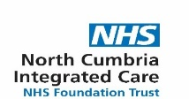

FINAL NASAL FLU CATCH UP SESSIONS

The following clinics have been arranged for children who missed their school nasal flu immunisation who are school years Reception –year 7:

Wednesday 27th January 2021 2 pm -6 pm at the following locations

Barrow 102 Dalton Lane - Furness General Hospital
2pm -6pm
&
Kendal Blackhall Unit - Westmorland General Hospital
2pm -6pm

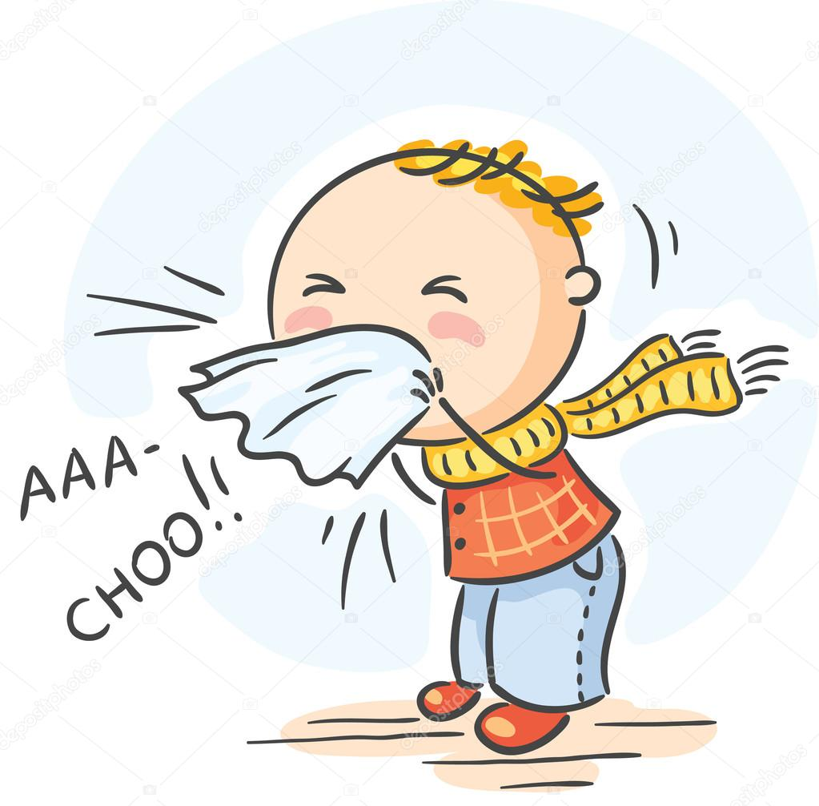

Please note you may be asked to wait in your car if the session is busy due to covid restrictions.

